

- GSKDirect Customers: www.gskdirect.com
  - Prebook for next season’s flu (2026-27) will open on December 2nd, 2025, at 12PM EST
  - Eligible customers with a pre-book reservation by March 31, 2026, will receive a 2% discount on their prebooked doses
  - Prompt Pay is 2% net 90 days
  - Returnability: 15% of all doses purchased are eligible for full credit return. Please communicate returnability to members so they are informed when prebooking.
  - Delivery guarantee: Customers who prebook on or prior to 3/31/2026 are eligible for a delivery guarantee and will receive a discount for late delivery, at the fault of GSK, after the following dates:
    - Receive a 10% discount if doses are made available after 10/18/2026

- Authorized wholesalers and distributors: Terms and conditions are dependent upon an account’s respective wholesaler/distributor. Please reach out to your primary wholesaler rep for details.

- GSK Flu resources can be found at:
  - https://gskvaccination.com/influenza/ and https://www.gskflu.com
  - GSK Service Center- 866-475-8222 for questions

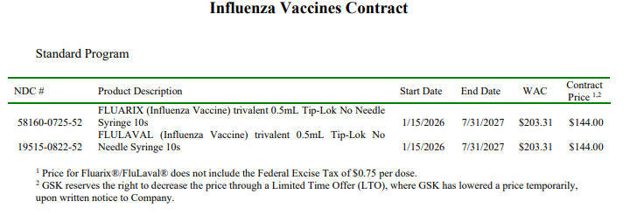

FLUARIX (Influenza Vaccine)
FLUARIX is a vaccine indicated for active immunization for the prevention of disease caused by influenza A subtype viruses and type B virus contained in the vaccine. FLUARIX is approved for use in persons aged 6 months and older.

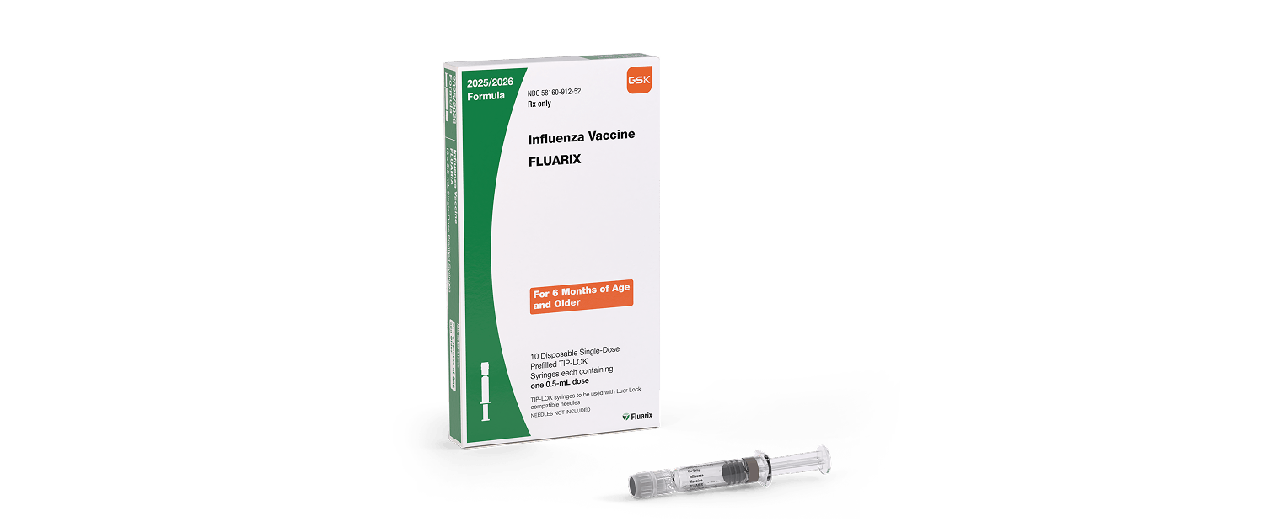

FLULAVAL (Influenza Vaccine)
FLULAVAL is a vaccine indicated for active immunization for the prevention of disease caused by influenza A subtype viruses and type B virus contained in the vaccine. FLULAVAL is approved for use in persons aged 6 months and older.

